**BRISINGA EXAMS – 2024 SERIES**

**MUSIC PP3 SCHEME**

1. (a)Continue the following opening to make a 16 bar melody for voice modulate to the subdominant before returning to the tonic. Introduce sequence and a triplet.

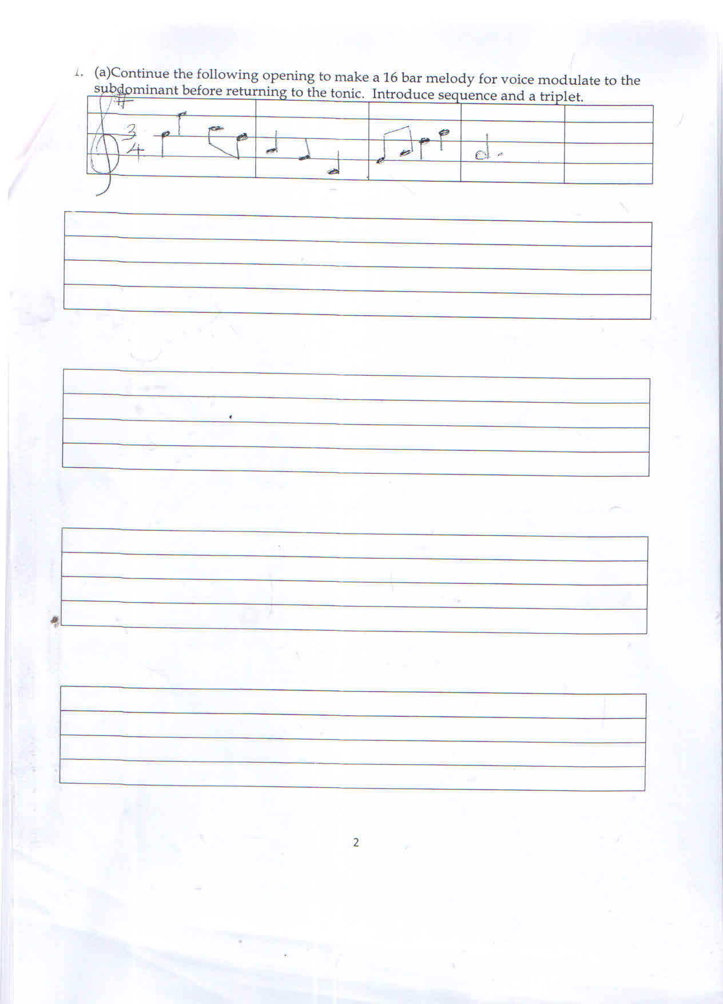

* ***16 bars (1 mk)***
* ***modulate and back (2 mks)***
* ***Cadences (2 mks)***
* ***Lyricism (1 mk)***
* ***Climax (1 mk)***
* ***Triplet 1***
* ***Sequence 1***

***TOTAL 9 MKS***

b) Using the text below, compose a melody in staff notation and fix to the text. Add phrase marks (6 mks)

Tukijikaza kimaisha, sote tutaimarika,

Sote tutasonga mbele, tutajikwamua sana.

* ***Syllabic division (1 mk)***
* ***Stress/speech rhythm (! mk***
* ***Lyricism (2 mks)***
* ***Codences (1 mk)***
* ***Variety of rhythm (1 mk)***

***Total 6 mks)***

1. Harmonize the following for Soprano, Alto, Tenor and Bass (SATB). Choose appropriate chords from the following

I, II, IV, V and VI

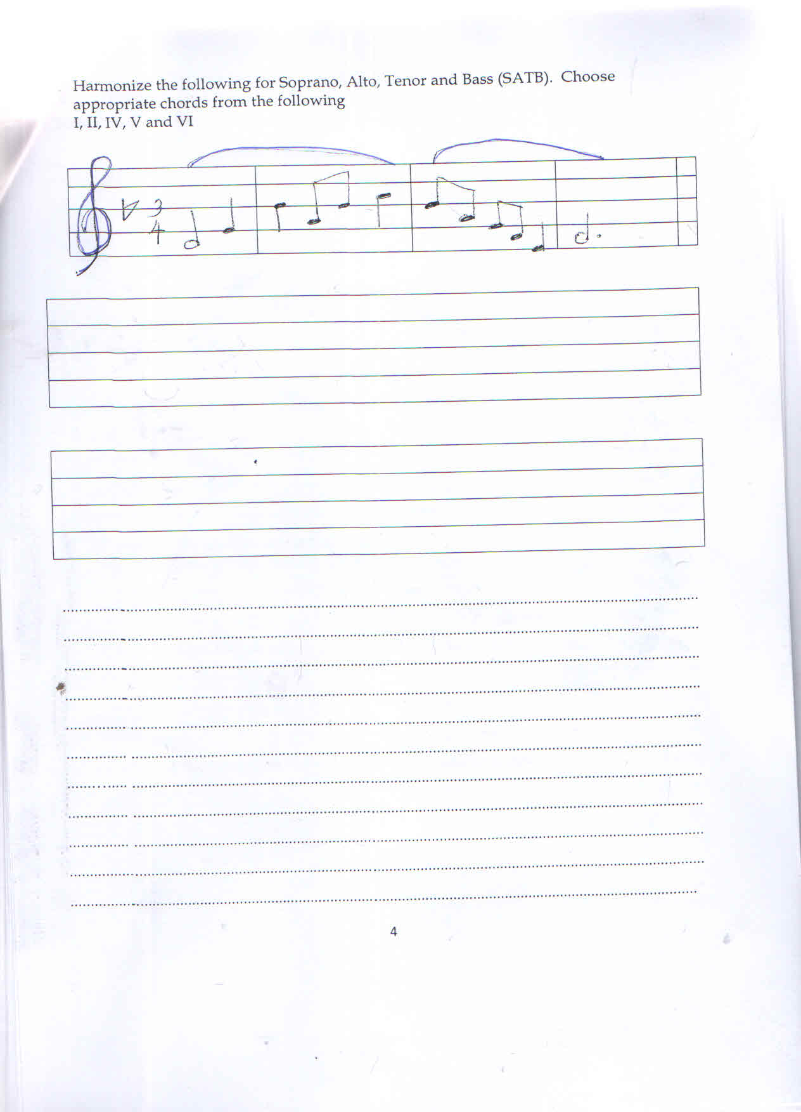

* ***Chords (12 chords x ½ ) = 6mks)***
* ***Cadences (end of each phrase) 2 mks)***
* ***Voice leading ATB = 1 ½ mks)***
* ***chord range ATB 1 ½ mks)***
* ***Chord progession 4 mks***
* ***Total 15mks***

***Deductions***

* ***Consecutive parallel 5th loctaves and unisons***
* ***voice crossing***
* ***overlapping***
* ***exposed 5th and octaves***
* ***wrong stems***
* ***Doubled 3rd in primary chords***
* ***wrong rhythm***
* ***missing brace***
* ***missing time signature***

1. **SECTION B : HISTORY AND ANALYSIS**
2. **i) AFRICAN MUSIC**

State three differences between a lyre and a harp (3 mks)

* ***A harp has five strings - Lyre has 6 – 8 strings***
* ***Aharps strings resonator at on angle lyrics strings runs parallel to each other***
* ***A harp has a curved neck while a lyre has two arms that run parallel to each other. (3x1)***

ii) Name two techniques of producing different sounds on an African traditional drum.

(2 mks)

* ***By cord bracing***
* ***Warming at fir***
* ***Warming in sun***
* ***pouring cold water on a highly pitch drum.***

1. Morobo is a traditional Kenyan dance.
2. Name the community that performs the dance. (1 mk)

* ***Agikuyu***

1. Name two occasions during which the dance is performed (2 mks)

* ***During singing games***
* ***During children dances(2 x 1)***

1. Outline four functions of music in African Traditional therapy. (4 mks)

* ***To soothe the sick***
* ***To heal the sick***
* ***To dispel the evil spirit from the sick***
* ***To warn the witches that causes sickness***
* ***To appeal the Gods for mercy***
* ***To appeal the Gods***
* ***To comfort the sick***
* ***To entertain those present***

1. Identify flutes from the list of instruments (2 mks
2. Murenge: ***Kikuyu flute***
3. Ndururet: ***Kalenjin and Samburu flute***
4. Aregeregeret: ***Iteso single string fiddle***
5. Ekegogo: ***Kuria single string fiddle***
6. **WESTERN MUSIC ANSWER ANY TWO QUESTIONS**
7. **THOMAS TALLIS**
8. Name Thomas Tallis’s nationality (1 mk)

* ***An English composer(1x1)***

1. Name some three characteristic features of his Aglican chant. (3 mks)

* ***It was sung in English – used psalniodic***
* ***Used reciting note – Vocal***
* ***It was antiphonal – used modes***
* ***Was strophic in nature – harmonized in 4 parts***
* ***Used both metrical and un metrical text in the same phrase***

1. Mention two of his works (2 mks)

* ***Composed masses***
* ***Latin motets***
* ***Elizabeth motet***
* ***English service music***
* ***English anthems***
* ***Key board works***
* ***Consent music***
* ***six voice antiphone***

***(2x1)***

1. Name one of his keyboard works (1 mk)

* ***Clarifica me pater***
* ***Remember Not, O lord God1 = 1***

1. **GEORGE FREDRIC HANDEL**
2. Name the period of Western history Handel lived (1mk)

* ***Baroque period***

1. Name three of Fredric Handel’s contribution to the music of Baroque period

(3 mks)

* ***He introduced carillo – a set of drums is orotances***
* ***increased the number of trumpets to four orotances***
* ***he introduced da capo aria – A – B – A structure***
* ***Composed ovatorius operas contetes (3x1)***

1. Name two of his appointments (2 mks)

* ***An organic at the Royal Academy of***
* ***Composer, violinist and harpsichordist music opera House orchestra in Hamburg***
* ***Music director to the royal Academy of musi.***
* ***kapellmeister to the elector of Harnnoves (2x1)***

1. Name one of his church music (1 mk)

* ***Coronation anthems or accession of George II***
* ***Deltingen Te Deum***

1. **CARL PHILIP EMMANUEL BACH**
2. When was he born? (1 mk)

* ***8th March 1714-14th December 1788(1x1)***

1. State three factors that influenced CPE to be a musician (3 mks)

* ***His father was a renowned musician***
* ***Taught keyboard lorgar by his father***
* ***was taught composition by his father***
* ***it Bach influenced CPE’s maturing style***

1. Name three keyboard sonatas composed by CPE Bach (3 mks)

* ***Keyboard sonator in A minor***
* ***Key board concert in F major***
* ***Key board concerto in F MAJOR***
* ***Key Sonatina E minor***

**D. FRANZ SCHUBERT**

i) When was Franz Schubert born? (1 mk)

* ***1797 – 1828***
* ***An Austrian composer (1 x 1 = 1***

ii) Mention four musician who influenced Franz Schubert to be a musician (4 mks)

* **The family was musical and cultivated string quartet playing in the home where Schubert played the viola.**
* **His father gave him his first violin lessons**
* **His elder brother gave him piano lessons**
* **outside the family he was taught by Michael Holzer organist and choirmaster of the local parish church in Lichtenthal**
* **Hozer instructed him to piano, organ and figured bass**
* **was influenced by Ludwig van beathoren W A Mozart. (4 x 1)**

iii) Name two of his works (2 mks)

* ***600 songs/liender including 3 cycles e.g the maiden of the mill, winter journey***
* ***10 symphonies***
* ***theatre music***
* ***piano solo***
* ***Church music***

1. **PRESCRIBED AFRICA ANALYSIS (10 MKS)**

**A KIPSIGIS PLANTING AND HARVEST SONG BY TENWEK PRIMARY SCHOOL (KMF)(10 MKS)**

1. i) Explain three ways in which variation has been achieved in the recording.

(3 mks)

* ***Talking at the beginning the singing common***
* ***singing different melodies***
* ***changing the cell and response style of singing***
* ***indusion of ornaments (ululations ) in some parts***

1. i) Name the main accompanying instrument used in the recording (1 mk)

* ***drum***

1. Explain how climax has been achieved in the recording (3 mks)

* ***Extended ululations***
* ***The chorus continue singing the stops abruptly***
* ***the performance stops abruptly***
* ***intensifying the drum***
* ***Intensifying the singing (3x1)***

1. **ANALYSIS OF PRESCRIBED WESTERN MUSIC**

**(O REST IN THE LORD) ARIA FROM ELIJAH BY FELIX MENDELSSONHN**

1. Name composition techniques that have been used in bars (3 mks)
2. 1 and 19: ***Repetition***
3. Bar one: ***syncopation***
4. 16 and 17: **Scalic movement**
5. What is the media of this work? (1 mk)

* ***Solo voice supported by the piano***

1. Give three roles played by the instrument in this work. (3 mks)

* ***Offer accompaniment – Play the preludes postuludes/intertude***
* ***play ornaments***
* ***provides harmony to the voice***
* ***Eutieve the performer***
* ***double the voice part***
* ***cue in the voice part***

1. What is the dynamic range of this piece (1 mk)

* ***from PP-P (Piano)***

***(very soft to sofa) 1(1x1=1***

1. Name articulation marks used in this work (2mks)

* ***Slurs, ties, pause***

1. **UNPREPARED ANALYSIS**

***Refer to the music below and answer questions that follow.***

***Allegro moderato 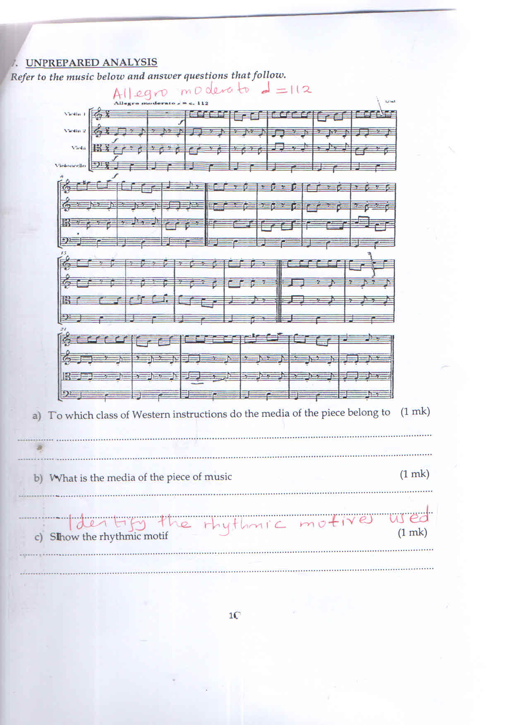 = 112***

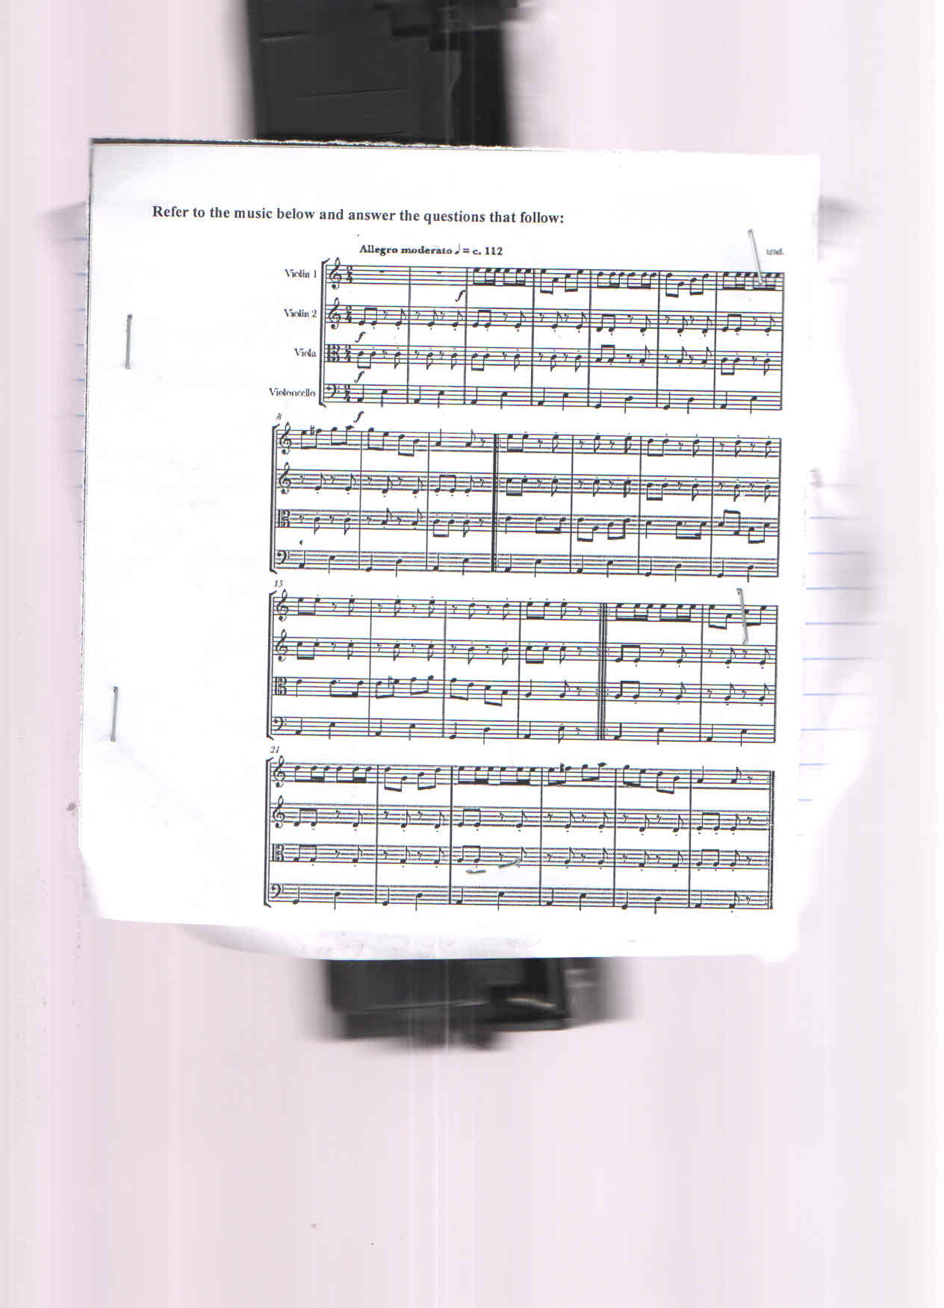

1. To which class of Western orchestra do the media of the piece belong to (1 mk)

* ***String family***

1. What is the media of the piece of music (1 mk)

* ***Instrumental***

1. Identify the rhythmic motives used. (1 mk)

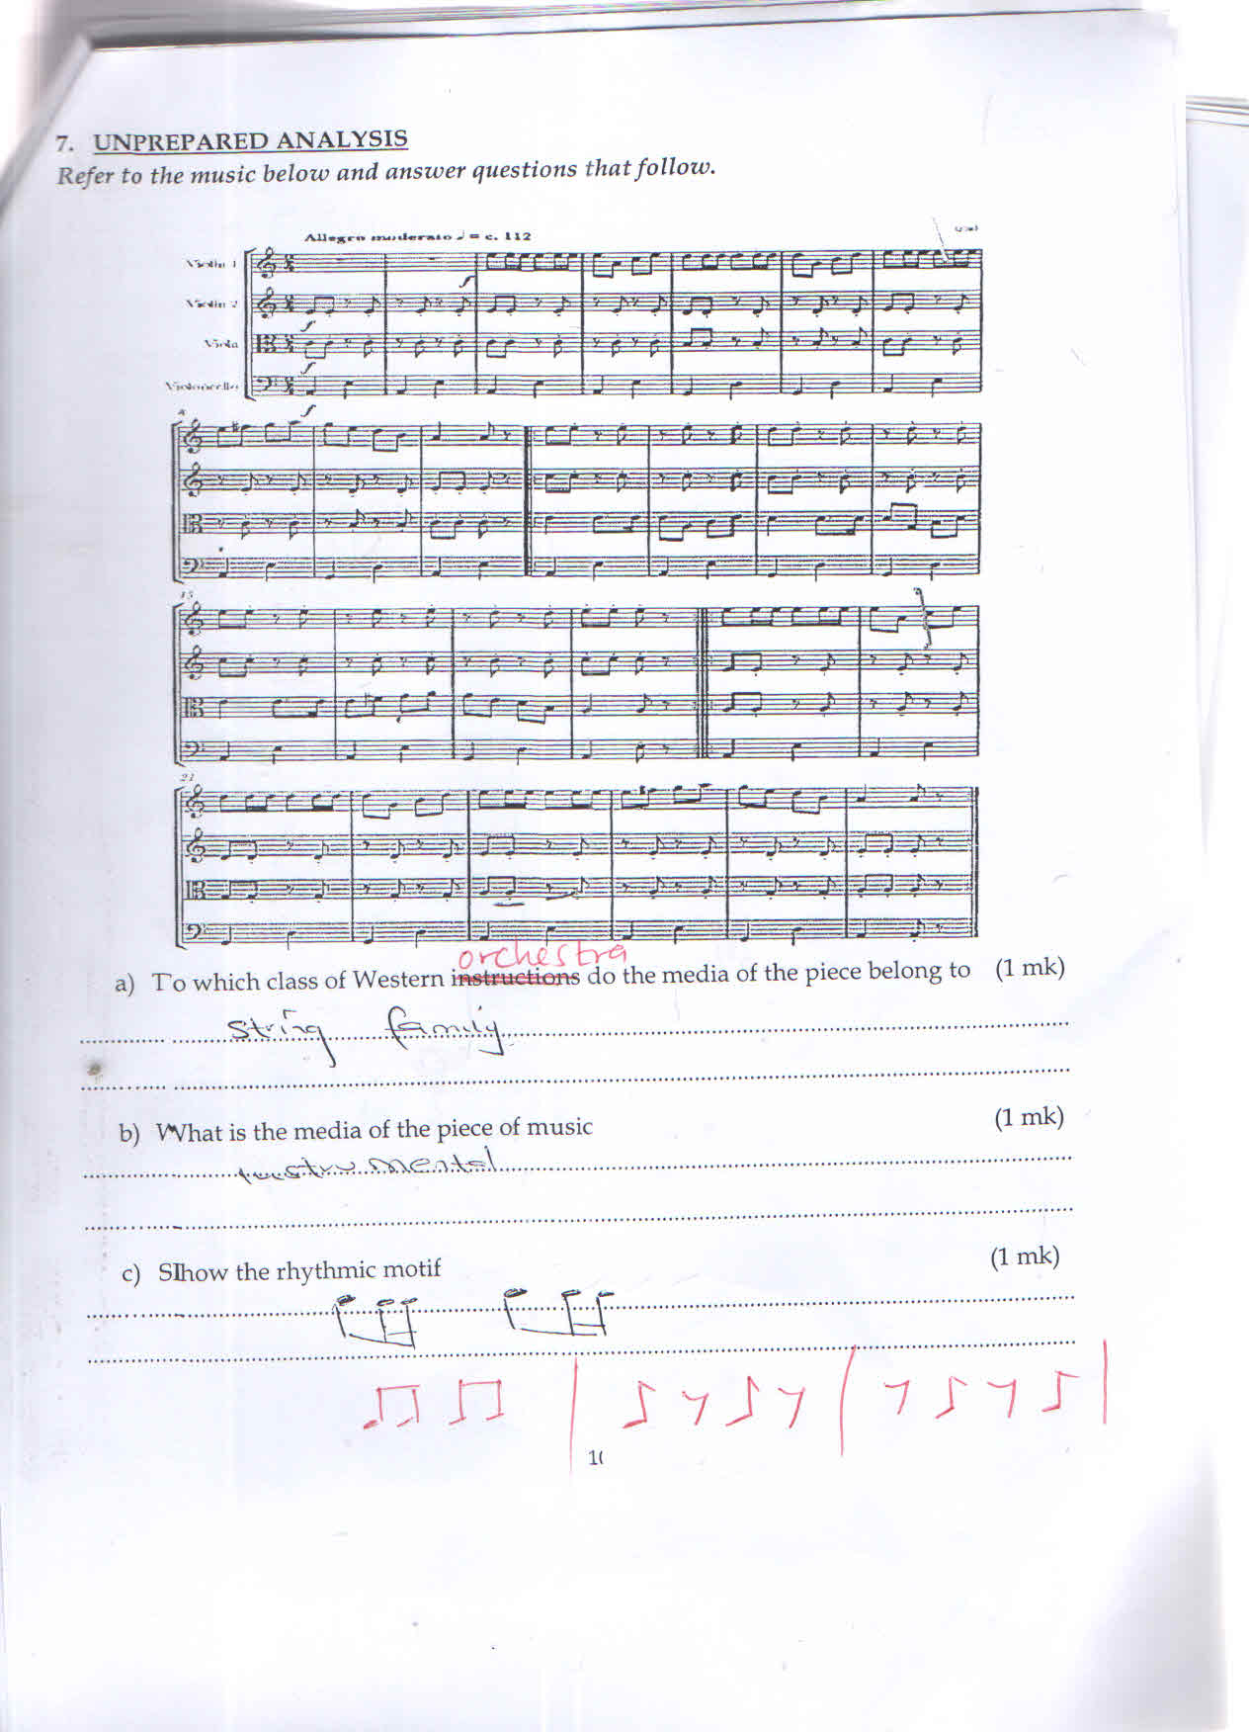

d) Rewrite the following on an open score by using treble, Alto, Tenor and Bass stares

(4 mks)

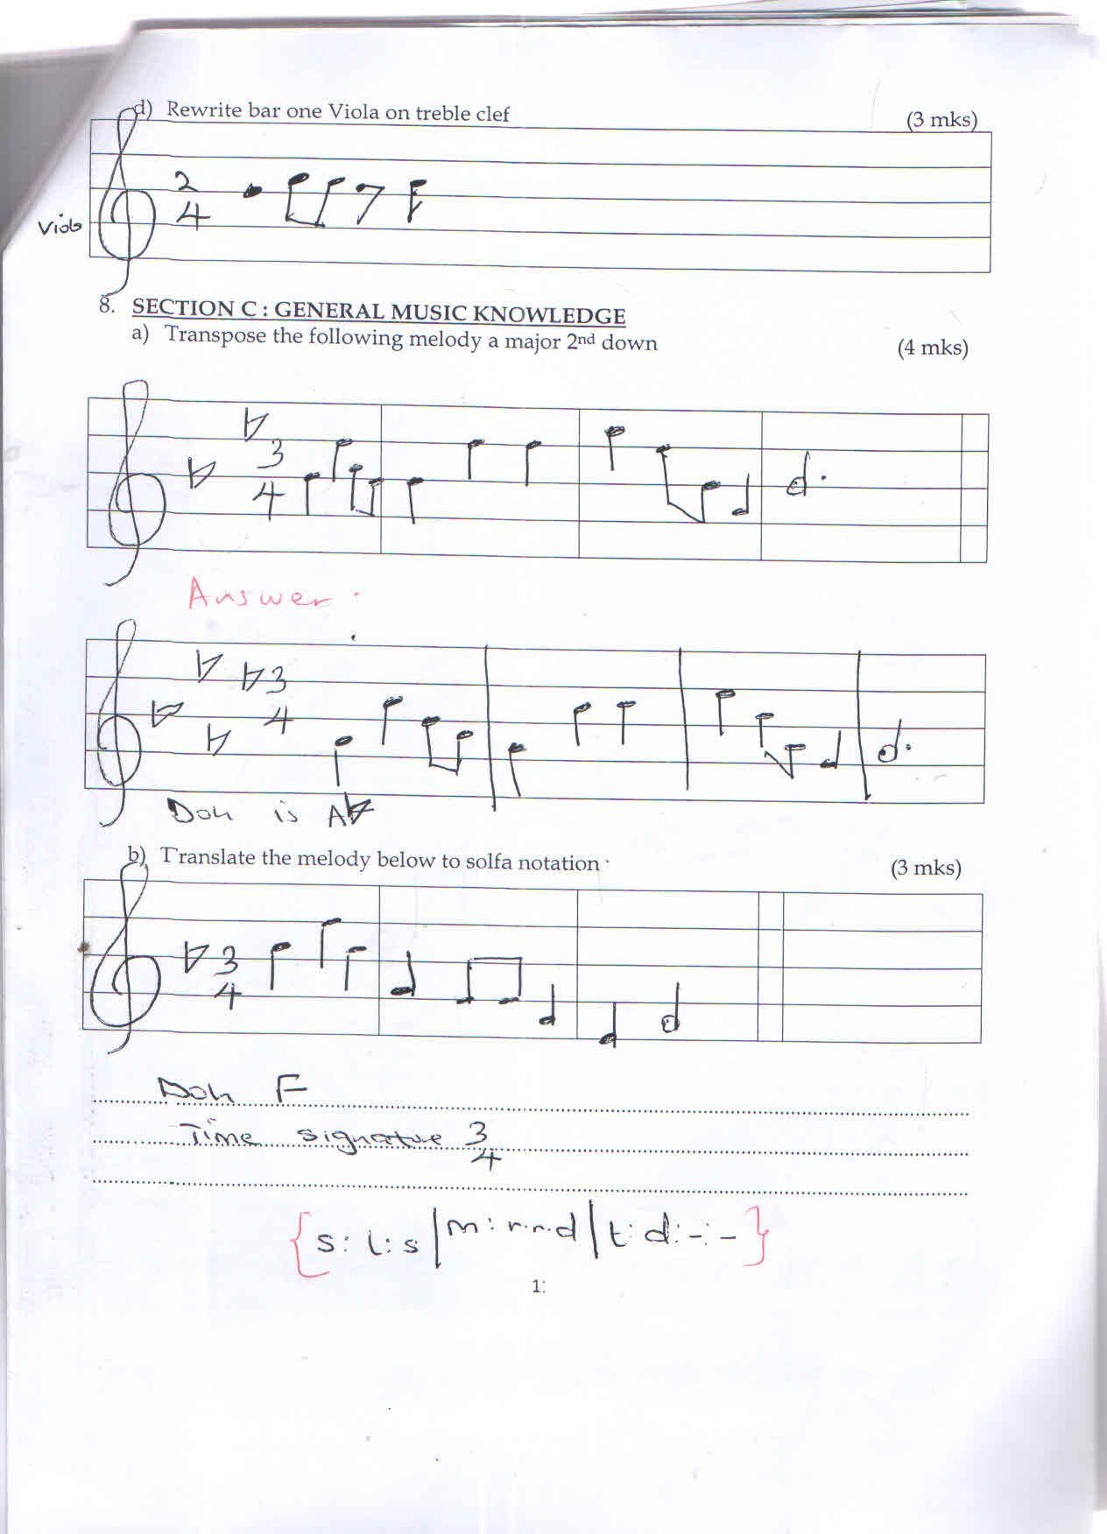

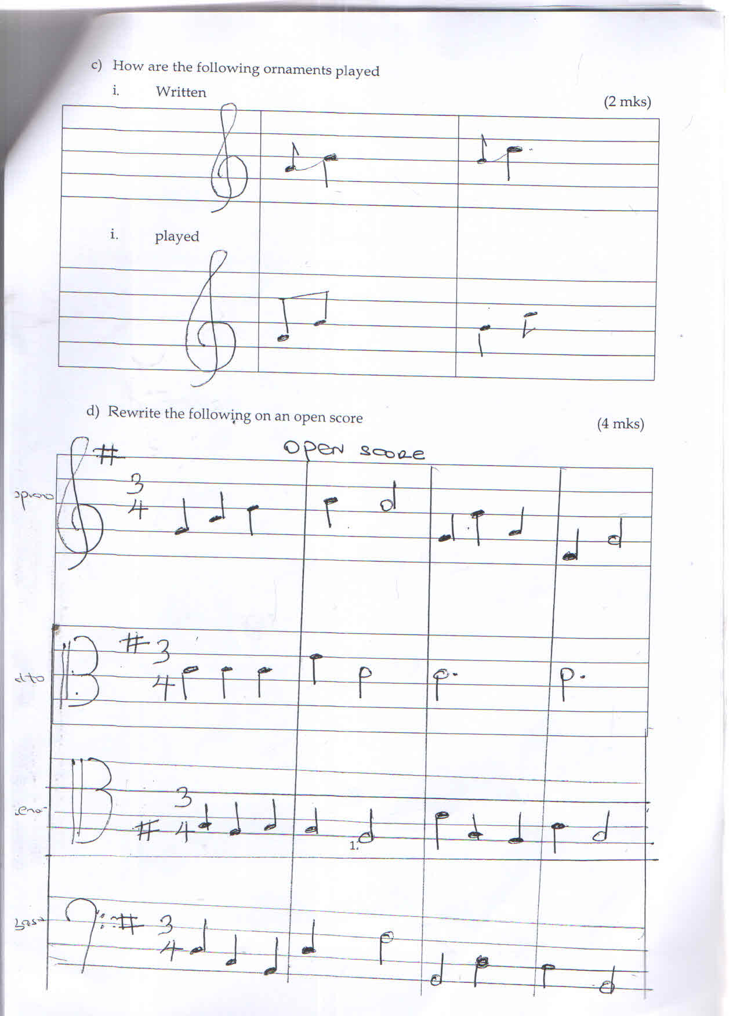

e) Explain the meaning of the following terms as used in music (2 mks)

1. Maestoso

* ***Majestically***

1. Poco a poco

* ***Little by little***

1. State and explain the role of costumes and décor in African traditional dances

* ***To attract the audience***
* ***Allow easy movement during dancing***
* ***To identify the community***
* ***To differentiate the singers from the dances(1x1)***